**Spikesort (A MATLAB-based spike sorter for NEV files)**

**Version: 2020XXXX**

Maintained by the Smith Laboratory ([www.smithlab.net](http://www.smithlab.net)). If you use Spikesort and find it useful (or if you have problems), please send us an email (matt@smithlab.net).

**Authors:**

*Ryan Kelly* - wrote the original version of Spikesort in 2006 while he was a PhD student at CMU

*Matthew Smith* - worked with Ryan Kelly on the original version, and led development since 2011

*Adam Snyder* - extensive development of Spikesort from 2012-2018 while at Pitt/CMU as a postdoc

*Shruti Vempati* - contributed bug fixes and improvements in 2016-2017 while she was a BioE undergrad at Pitt

*Xiaohan Zhong* - updated code and added features in 2018 prior to the GitHub initial release

**Publishing data using Spikesort**: If you use it in work you're going to publish, we would appreciate it if you would acknowledge us. You could put the software name and Github URL in your paper, or you could cite one or both of these references:

* Kelly RC, Smith MA, Samonds JM, Kohn A, Bonds AB, Movshon JA & Lee TS (2007) Comparison of recordings from microelectrode arrays and single electrodes in the visual cortex. Journal of Neuroscience, 27: 261-264
* Kelly RC (2010) Statistical Modeling of Spiking Activity in Large Scale Neuronal Networks, Ph.D. Thesis, Carnegie Mellon University

**DISCLAIMER:** Spikesort is intended for sorting spike waveforms in NEV files (native format of Blackrock and Ripple hardware). This software modifies the NEV files and rewrites the sort codes for the channels. The authors of Spikesort take no responsibility for any errors in the software or in its use with your data. Remember that Spikesort modifies the NEV file, so you should have a backup before running this software. You should check that the sorting did what you thought it did with your NEV file. YOU ARE RESPONSIBLE FOR YOUR OWN DATA! That said, Spikesort continues to undergo development and has been used extensively. Bugs have existed in the software and will exist again, but it is relatively robust and mature.

**Main File List**

*genSpikeMapColor.c + mex-compiled* files - take waveforms and produce an image shown in the GUI

*genSpikeMapColorMatlab.m* – [NOT USED] this is a slower Matlab-native code version of genSpikeMapColor.c

*getSNR.m* - calculate SNR (signal-to-noise ratio) - see Kelly et al 2007 (Journal of Neuroscience, 27: 261-264)

*loadSort.m* - load the saved sort file

*manageTempFiles.m* - manage temporary Spikesort files

*readSampleWaveforms.m* - load a subset of spikes for sorting

*readWaveforms2.m* - read the waveforms, times and units

*readWaveforms2_timer.m* - uses a timer function so that it can run in the background

*readWaveforms2_timer_sparse.m* - does a sparse (limited) read of waveforms for speed

*rubberbandbox3.m* - draw a rubber band box and return the start and end points (for selecting spikes)

*rubberBandMotionFunction.m* - window motion callback function

*saveSort.m* - save a sort to a specified location

*spikesort_gui.m* - define the operation callbacks

*spikesort_nevscan.m* - read the NEV file & get file information (called when a set of files are loaded)

*spikesort_write2.m* - called to write the sort codes to the NEV file

*spikesort.m* - spikesort main function

**Utility File List** (in some cases these are not standalone, and call other Spikesort functions)

*chanPlot.m* - plot the spike waveforms for specified channel(s) with various plot options

*justSNR.m* - return channels list, sort codes, SNR values and spike counts (and average waveform)

*moveToSortCode.m* - write a list of sort codes into a NEV file

*plx2nev.m* - take a PLX file and convert it to NEV file with the same file name but a NEV extension

*plxSortFromNEV.m* - take a NEV-converted PLX file & write sort codes back into the PLX file

*read_nev.com* – reads spikes and events from NEV file, along with waveforms

*waves2nev.m* - take waveforms, channels, sort codes, times and write them into a NEV file

**Notes**

**Mex Files**: Spikesort uses a Mex-compiled C function (genSpikeMapColor.c) to speed up generating the waveform image for display. This function is currently compiled for several platforms. If you need to recompile, go to the Spikesort directory and type "mex genSpikeMapColor.c". Alternatively, there is a matlab-native version (genSpikeMapColorMatlab.m), but it is much slower.

**NEV files**: Spikesort works on NEV files, the native data format for Blackrock and Ripple hardware. If you have data from another recording setup, you can export your waveforms and convert them to a NEV using the waves2nev.m function supplied in the Spikesort directory. Also plx2nev.m converts Plexon PLX files to NEV.

**Performance:** Spikesort creates temporary sort files of in-progress sorts. When you first run Spikesort, it will ask you where to store these files (you can change the location in the GUI). It will create a "spikesortunits" folder that contains ch*.mat and hist*.mat files. These are the cached waveforms and the sorting history for each channel. It cleans up that directory and creates a tempsort_*.mat file on exit. The speed of Spikesort will be affected strongly by the disk access speed of the NEV file and also of this spikesortunits directory.

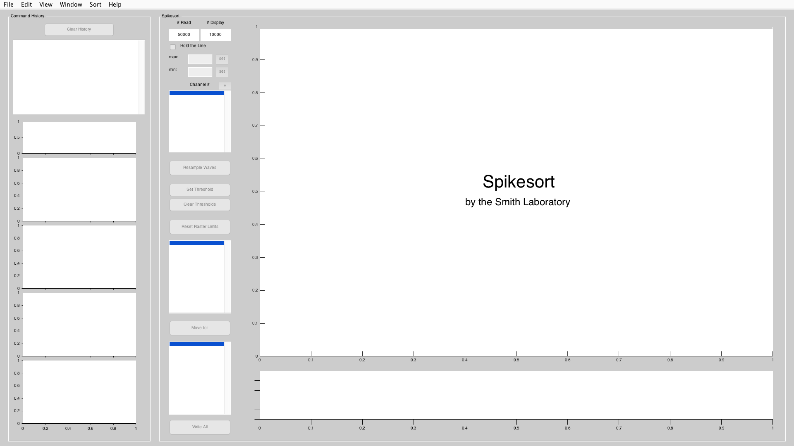

**Spikesort GUI**

Figure 1

**Opening Spikesort and loading data** (Before getting started add the spikesort directory to your path)

**Method 1: Using the GUI**

* Open Matlab and type “spikesort”
* Loading Options: Under File (Figure 2) change loading options before loading data (Sparse load). Click on the text and a check mark will appear next to the selection. Read more about loading options below.
* Load Data: Under File select “Load data”. Load single or multiple files to sort (Figure 3).
* You can use shift or control modifiers to select multiple files
* Files will always be sorted alphabetically from the list of files selected.

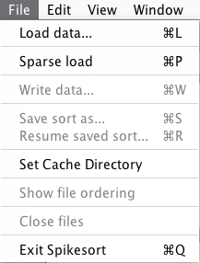

Figure 2

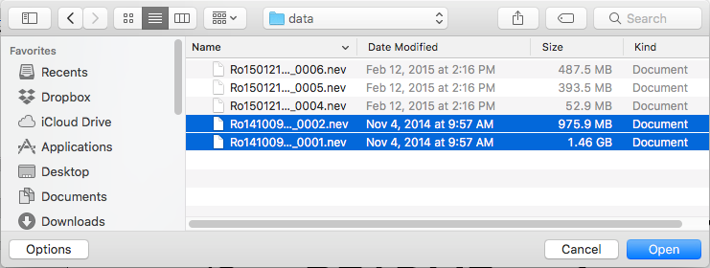

Figure 3

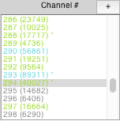

Figure 5

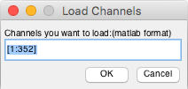

Figure 4

18

8

**Method 2: Using the command line**

* All the loading options in the GUI are available at the command line.
* Spikesort accepts one or multiple files at once. All file inputs must be cell arrays. It also accepts optional input arguments ‘doSparse’ and ‘noSort’.
* ’doSparse’ enables the sparse read capability. It can be logical input or positive integer which specifies the subset number of waveforms when loading. Default is false.
* ‘noSort’ disables the sorting of the cell array of input filenames, so you can specify a particular order. It can be logical input. Default is false (which means the input files will be sorted alphabetically).

(You can find the order of files by clicking ‘Show file ordering’ under ‘File’ Menu)

* Examples:

spikesort({'path/animal_date_task_0001.nev'}); spikesort({'path/animal_date_task_0002.nev','path/animal_date_task_0001.nev'},’noSort’, true);

spikesort({'path/animal_date_task_0001.nev’},’doSparse’,1000);

**Loading Options**

* Load Data: After selecting files a pop-up window (Figure 4) will ask which channels you want to load. In the “channel #” window in Spikesort the loaded channels will be in green text and unloaded channels will be in gray text (Figure 5).
  + After the initial loading, channels that haven’t been loaded can be loaded by double clicking the channel.
  + If you click multiple channels they will load in the order you clicked them. This will be written out in text above the spike window (best practice is to wait until a channel is done loading before trying to load another one).
  + If you click the “+” button, you have the option to select a range of channels to load (Figure 4).
* Sparse Load: load only specified number of units, speeding up the loading time
  + When checked in the GUI all future loading (double-clicking, etc.) will be sparse and show as blue text (Figure 5).
  + Default is set to 50000, this needs to be changed before loading the initial set of data or it will be locked in for the remainder of sorting.
  + Use ‘doSparse’ as an argument at the command line as well. The default is 50000 but can be by specifying it in the input.
    - spikesort({‘datafile.nev’},’doSparse’, 50000)
* Double clicking grayed channel: this will automatically load in the background. If sparse load is checked the files will be sparse loaded.

**Loading and Writing Without GUI (for batch processing)**

* This can be used to create “tempsort” files, or to write NEV files if “tempsort” files already exist.
* ‘readOnly’: Default is false. Setting to true loads the channels and saves them in a temp sort without opening the GUI. Thus, a script could do this for many NEV files, caching them for faster sorting later.
* ‘readOnlyWithNasnet’: Default is false. Setting to true loads the channels, sorts with NASnet (Read more about NASnet sort in sorting options), and saves thems in a temp sort without open the GUI.
* ‘readOnlyWithMoG’: Default is false. Similar to ‘readOnlyWithNasnet’ but sorted with MoG sort (Read more about MoG sort in sorting options).
* ‘readOnlyChannel’: Specify the channels you want to load. Only valid when ‘readOnly’, ‘readOnlyWithNasnet’ or ‘readOnlyWithMoG’ is true. Default is true, which means all channels, but you can also list only the channels you want loaded.
* If more than one of ‘readOnly’, ‘readOnlyWithNasnet’ and ‘readOnlyWithMoG’ are set to true. The priority order should be MoG, Nasnet, readOnly and it only choose the highest priority to apply.
* ‘writeOnly’: Default is false. Specifying it as true enables loading the temp file and writing it automatically, as long as only one valid temp sort exists for the NEV file specified. If multiple corresponding temp files are found, writing will be terminated.
* Examples:

spikesort({‘datafile.nev’},’readOnly’,true,’readOnlyChannel’,1:10)

spikesort({‘datafile.nev’},’readOnlyWithNasnet’,true,’readOnlyChannel’,1:10,’gamma’,0.2,’net’, 'UberNet_N50_L1_', ‘sortCode’, [ 255 0])

spikesort({‘datafile.nev’},’readOnlyWithMoG’,true,’readOnlyChannel’,1:10, ’gamma’,0.2,’net’, 'UberNet_N50_L1_', ‘sortCode’, [ 255 0])

spikesort({‘datafile.nev’},’writeOnly’,true)

**Setting Cache Directory**

The first time Spikesort is opened it will ask you where you want to store your files. This is also where temporary files will be stored. If you ever want to change where that directory is just go to file, then click “Set Cache Directory” (Figure 2).

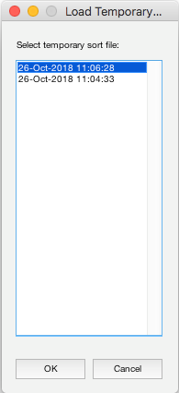

Figure 8

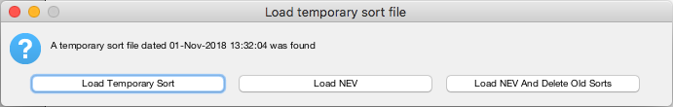

Figure 6

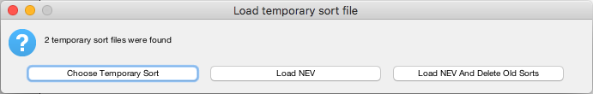

Figure 7

**Loading temporary sorts**

Anytime Spikesort is closed and data hasn’t been written or saved, a temporary sort file is saved to the cache. When opening a datafile that has a temp sort, one of two pop up windows will prompt you to either open a temp sort, open the NEV, or load NEV and delete temp sort (Figure 6). If more than one temporary sort file is found, it will ask if you want to pick one of them (Figure 7). A second window will pop up if you have more than one sort to choose from (Figure 8).

**Sorting Options**

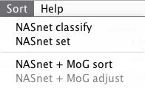

Figure 9

Automatic sort options are under the ‘Sort’ menu (Figure 9).

* NASnet set: choose the neural network. If not choose your own network, the default neural network will be used. (Figure 10)
* NASnet classify: Enter the channels you want to run NASnet on, specify the gamma (needs to be smaller than 1 and bigger than 0). Each waveform has a spike value calculated from the neural network (0 for likely noise and 1 for likely spike, with continuous values in between). The waveform is given a different sort code based on the spike value from NASnet and the gamma value.

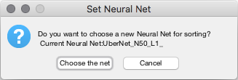

Figure 10

The default channel is the channel you choose before you enter the menu, the default gamma is [0.2] and the default sort code is [255 0]. (Figure 11)

* For example:

gamma = [0.2 0.4] and sort code = [255 0 1]

|  |  |  |  |
| --- | --- | --- | --- |
| Label value | 0 🡨 🡪0.2🡨 🡪0.4🡨 🡪1 | | |
| Sort code | 255 | 0 | 1 |

For each wave, if label value is bigger than 0 and smaller than 0.2, sort code will be 255; if label value is bigger than 0.2 and smaller than 0.4, sort code will be 0; if label value is bigger than 0.4 and smaller than 1, sort code will be 1.

Note:

1. The number of sort codes has to be one more than the number of gamma values.
2. The gamma value has to be increasing and in the range of (0,1).

* NASnet and MoG sort: Enter the channels you want to do NASnet and MoGsort on, MoG sort will estimate the number of clusters (n) and set the sort code (1,…,n) for each spike. Then, NASnet will separate waves as noise and spikes based on the gamma value, and change noise wave’s sort code to 255.

Note: The gamma value has to be a single value and in the range of (0,1). (Figure 12)

* NASnet and MoG adjust: This option will be enabled once NASnet and MoG sort has sorted this channel. You can edit gamma value and number of clusters to resort the waves. (Figure 13)

Note: Other MoGsort options are defined in mogSortOptions.m file, which can be edited there.

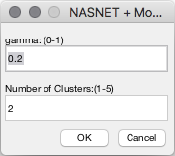

Figure 13

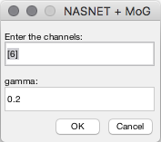

Figure 12

Figure 11

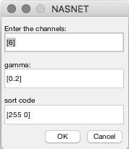

**Spikesort GUI Introduction**

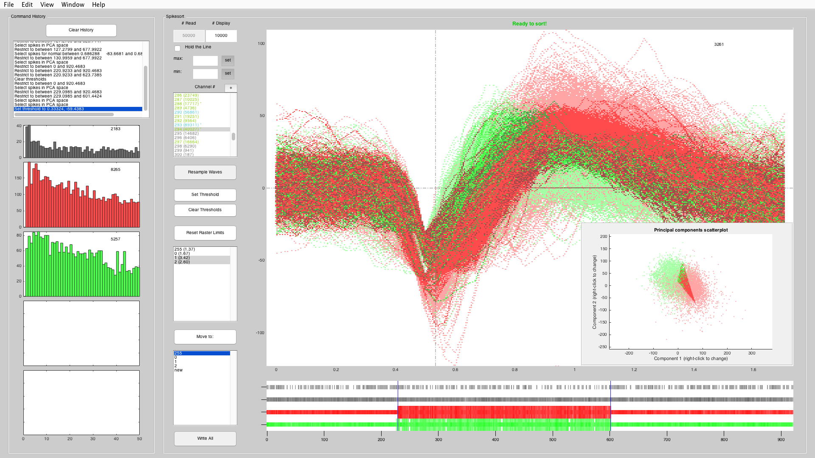

10

9

8

6

5

1

3

11

12

13

14

2

4

16

7

15

17

8

Figure 14

1. **Main sorting window**. Waveforms from selected sortcodes (see [2]) are displayed here for manual sorting.  
   The x-axis measures time (in milliseconds) and the y-axis measures voltage (in millivolts).  
   *If no waveforms are selected, (given by the integer in the top-right corner of the window)*

* Left click and drag to create a rubber band box that selects all waveforms passing through it.
* Right click and drag to create a rubber band box that selects all waveforms not passing through it.

*If waveforms are selected,*

* Left click anywhere to deselect all waveforms.
* Left click and drag to select a new set of waveforms, as above.
* Right click and drag to create a rubber band box that deselects the subset of selected waveforms that passes through it.

*Relevant keyboard shortcuts (Only active when “current axes” is the main sorting window)*

* Up/Down arrow keys: Change channel, see [11]
* Left/Right arrow keys: Change sortcode, see [2]

1. **Selected sortcodes**. Waveforms from sortcodes selected in this listbox appear in the main sorting window. Sortcodes 1-254 are intended to store spiking waveforms, while 0 and 255 are to store noise.  
   For each sortcode, the signal-to-noise ratio (SNR) of all of its waveforms is given in parenthesis.  
   *Relevant keyboard shortcuts (Only active when “current axes” is the main sorting window)*

* Left/Right arrow keys: Change sortcode

*Note: Actions in the main sorting window operate only on selected sortcodes. Multi-select supported.*

1. **Rubber band box**. Select/deselect waveforms in the sorting window. See [1].
2. **Selected waveform destination**. The "Move to:" button moves all spikes selected in the main sorting window into the sortcode highlighted in the listbox beneath it.  
   If no waveforms are selected or waveforms are moved to the same sortcode, nothing happens.  
   If waveforms on one or more sortcodes are selected, they are all moved to the destination sortcode and remain selected in case of user error. For more on handling user errors, see [6].  
   *Relevant keyboard shortcuts (Only active when “current axes” is the main sorting window)*

* 0, 1, 2, 3, ...: Move selected waveforms into sortcode #.
* (Windows) Delete: Move selected waveforms into sortcode 255. (Mac: Fn+Del)

1. **ISI histograms**. Distributions of inter-spike intervals (ISIs) for each sortcode. Useful secondary factor to consider when making sorting decisions. The x-axis measures time (in milliseconds) and the y-axis is a count of waveforms.
2. **Command history**. Full sequence of all sorting commands executed on the present working channel.  
   Double clicking any previous command will undo all commands that follow it in the menu; pressing the "Clear History" button will undo all commands, resetting the channel.  
   *Relevant keyboard shortcuts (Only active when “current axes” is the main sorting window)*

* (Windows) Backspace: Move backward one command in the history (Undo). (Mac: Del)

1. **Spiking raster**. Spiking raster plots of waveforms on each sort code across the length of the data. Multiple datasets being sorted simultaneously are put back-to-back, separated by a black vertical line (not shown).  
   Only spiking waveforms that occurred within the blue vertical bars are shown in the main sorting window.  
   *To restrict the waveform viewing window,*

* Left endpoint: Left click once to bring up a crosshair. Left click again to move the left endpoint (left blue vertical bar).
* Right endpoint: Right click once to bring up a crosshair, again to move the right endpoint (right blue vertical bar).
* While the crosshair is active, press (Windows) Backspace to reset the viewing window to the fulltime interval. (*Mac*: Fn+Del)

*Note: Actions in the main sorting window operate only on waveforms within the waveform viewing window.*

1. **Number of sparse read waveforms**. Default 50000. Number of waveforms read when sparse read selected. If the total number of waveforms for selected electrode channel is smaller than the number of sparse read waveforms, all waveforms will be read instead of sparse read. It can only be changed before loading a file.
2. **Number of display waveforms**. Default 10000. Number of waveforms shown in the main sorting window. Larger numbers risk slowing the GUI. It can be changed anytime.  
   *Note: ALL WAVEFORMS, not simply the visible ones, on selected sort codes are affected with sorting commands.*
3. **Constrain axes limits**. Place constraints on the y-axis of the main sorting window. Default behavior changes axis limits per channel to best display the waveforms within.  
   In the case of high-voltage noise waveforms on a channel, fill in some voltage in the "max:" box to set a maximum and reselect the channel from the channel selection box (see [11]).  
   If "Hold the Line" is checked, axes limits remain constant across sortcodes. If not, axes limit automatically change to best display the selected sortcodes.
4. **Channel selection window**. Selected electrode channel is active in the GUI workspace. Each loaded channel has its own independent waveforms, sortcodes, and command history.  
   Each list item gives channel number, followed number of waveforms on the channel in parentheses and an asterisk (*) if unwritten changes have been made. The list item is shown in green when the channel is fully loaded, in cyan when the channel is sparse read and in grey when the channel has not been loaded yet (Notification will be shown in main sorting window).

*Relevant keyboard shortcuts (Only active when “current axes” is the main sorting window)*

* Up/Down arrow keys: Change present working channel

1. **Resample waves**. Resample the waveforms showing in the main sorting window from the total read waveforms.
2. **Set threshold/Clear threshold**. Shift waveforms horizontally according to a selected y-axis (voltage) threshold.  
   "Set Threshold" opens a crosshair for the main sorting window. "Clear Thresholds" clears all existing thresholds, if there are any.  
   *When setting threshold (with left click in main sorting window),*

* Vertical placement of crosshair sets voltage threshold for any waveform that crosses it.
* Horizontal placement of crosshair determines alignment point for waveform shift.
* The first point that a given waveform crosses the set threshold is translated horizontally to be placed on the alignment point.

1. **Reset raster limits**. Reset the spiking raster plots to default.
2. **Write all**. Write all sorting commands to .nev file.  
   *Note: Save as tempsort *.mat file before making changes to original .nev file(s). Rest assured, the changes may be reversible, and the program will ask if you are completely certain that you wish to write the changes before doing so.*
3. **PCA scatter**. Click “Show PCA scatter” under “View” to get principle component analysis scatter plot. Each spike is represented by 5 components. Right click x-axis or y-axis to change the components. Each point on the scatterplot corresponds a spike on main sorting window. Left click on the plot to get “+” arrow, outline the points and right click to confirm, the selected points(spikes) have relatively dark color than the unselected ones.
4. **Show threshold**. Click “Show threshold” under “View” to draw horizontal lines of low threshold and high threshold, also draw a vertical line of timestamp of threshold location, which is where waveforms align when click “Set Threshold”.
5. **Exit Spikesort**. Exit Spikesort software.

*Note: Spikesort creates temporary sort files of in-progress sorts. In your current working directory in Matlab, it will create a “spikesortunits” folder that contains ch*.mat and hist*.mat files. These are the cached waveforms and the sorting history for each channel. It cleans up that directory and creates a tempsort_*.mat file on exit by clicking “Exit Spikesort” or “×”.*

**Updates since Spikesort 20190108**

1. Added NASNet sorting options
2. Updated MOGSort extensively
3. Added in batch read/write options from command line to load NEV files or write temp sorts without using the GUI. Useful for pre-loading several files for sorting, or for writing all the temp sorts in a batch.
4. Added readOnlyWithNasnet and readOnlyWithMoG options from command line to load NEV files or write temp sorts without using the GUI.
5. Remove background loading